President: Jacintha Wilmink | info@woumarec.nl
Secretary: Elin Jørgensen | elinj@sund.ku.dk
Treasurer/Membership Secretary: Michael Braun | treasurer@vwha.net

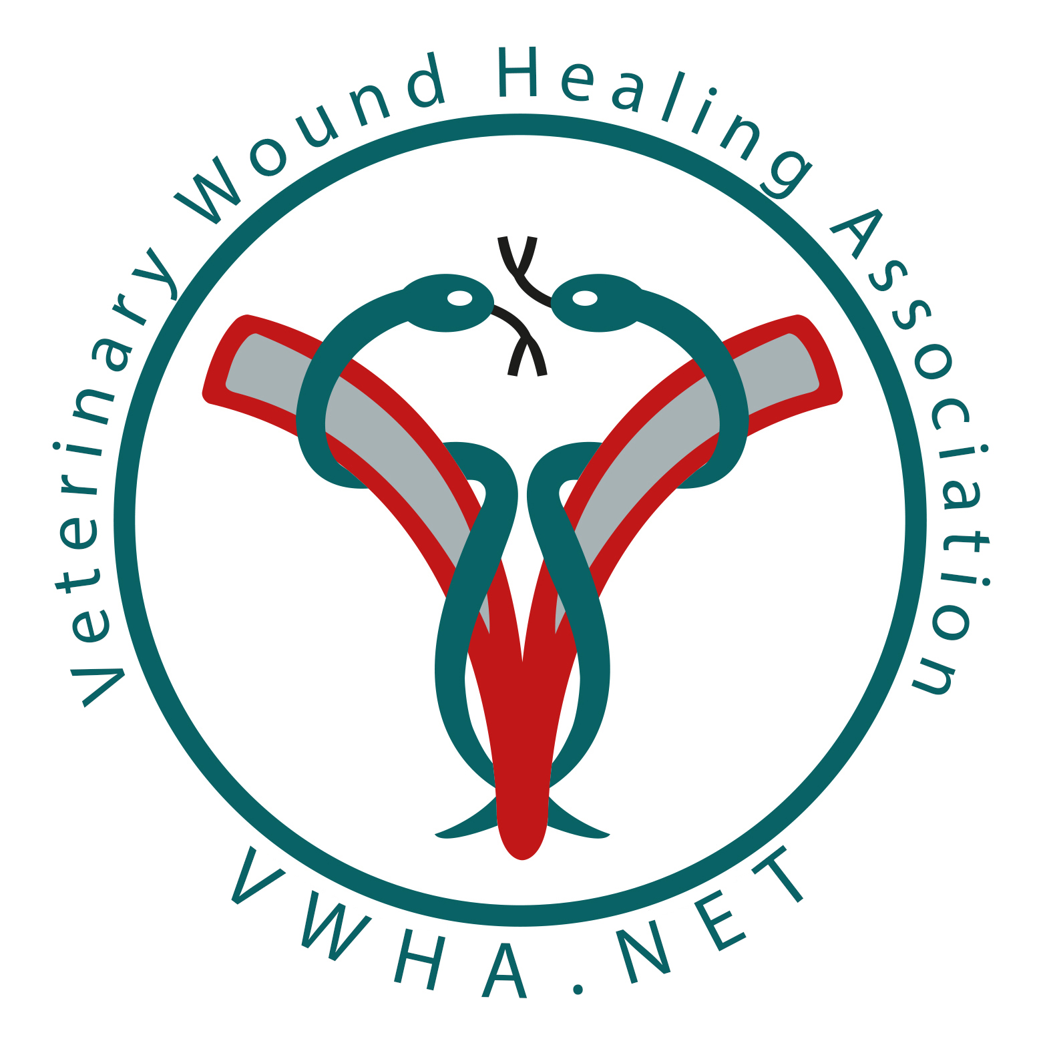

Preliminary agenda for the 2018 AGM of the Veterinary Wound Healing Association held
in Krakow, Poland 11th May 2018

Agenda for the 2018 AGM of the Veterinary Wound Healing Association held
in Krakow, Poland 11th May 2018

- Apologies for absence:

- Minutes of the 2017 AGM
Minutes of the 2017 AGM were made available to members over 2018 via a dedicated section within the VWHA website.

- Matters arising from the minutes 2017

- Correspondence

- President’s report

- Treasurer’s report

- Election of council members and replacement of officers

- Scientific meeting/ courses 2018-2019
      - VWHA conference during EWMA Poland May 2018
      - Equine course and/or Small animal courses to be decided
      - VWHA conference during EWMA Sweden May 2019

- Issues to be discussed
- Strategy for the future of the VWHA

- Any Other Business.

